Deploy a simple web application using AWS code commit, code build and deploy & access via browser and automate via codepipeline.

CI/CD

CI/CD represents Continuous Integration and Continuous Delivery/Deployment. It is the backbone of modern DevOps, bridging the gap between development and operations by automating the building, testing, and deployment of applications.

Before CI/CD

In the past, software delivery was slow and full of manual work. Developers used to create separate feature branches and worked on them for weeks or even months.

All these branches were merged at the end, which often caused big conflicts and broken builds. Testing and building the code were also manual, usually done at the final stage, so bugs were discovered very late and were costly to fix.

Deployment was a long and risky process, taking days or sometimes weeks, because everything was released together in one big update.

Teams were also divided: developers wrote code, testers tested it, and operations managed servers.

After CI/CD

With CI/CD, the whole process became faster, automated, and more reliable. Developers now commit their code frequently to a shared main branch, which prevents conflicts and ensures smooth integration.

Automated pipelines run tests, builds, and checks as soon as code is pushed, so errors are caught early. Continuous Delivery makes sure that tested code is automatically packaged and ready for deployment

While Continuous Deployment takes it a step further by directly releasing to production without manual steps. This means smaller, frequent updates instead of one big risky release.

Tools like Git, Jenkins, Docker, and Kubernetes automate everything from building to deployment, making the workflow transparent and collaborative. Bugs are fixed quickly, rollbacks are easier, and overall software delivery happens in hours instead of days

The Three Pillars of CI/CD

To master CI/CD, you must understand the subtle but critical differences between the three "Continuous" concepts.

1. Continuous Integration (CI)

The Goal: Prevent "Integration Hell."
The Process: Developers merge their changes back to the main branch as often as possible (daily).

The Automation: Upon every commit, an automated system builds the code and runs unit tests.

If a test fails, the build is rejected, and the developer is notified immediately.

2. Continuous Delivery (CD)

The Goal: Be ready to release at any moment.

The Process: After CI passes, the code is automatically deployed to a staging/testing environment. Extensive integration and load tests are run.

The Release: The codebase is always in a deployable state, but the push to production is a manual decision (e.g., a "Deploy" button click by a manager).

3. Continuous Deployment (CD)

The Goal: Eliminate human intervention.

The Process: Same as Continuous Delivery, but if all automated tests pass in staging, the code is automatically deployed to production.

The Requirement: Requires extremely robust, trustworthy automated testing suites

CI Workflow

Below is a pictorial representation of a CI pipeline- the workflow from developers checking in their code to its automated build, test, and final notification of the build status.

When a developer saves (commits) their code to a version control system like Git, the CI pipeline starts. It takes the new changes, builds the project, and runs tests automatically. After that, the server tells the developer if adding the new code to the existing code worked or failed.

This helps find and fix bugs faster, saves developers from doing the same tasks again and again, and allows the team to release updates to customers more often. Studies show that using CI can save developers about 25–30% of their time.

CI and CD Workflow

The below image describes how Continuous Integration combined with Continuous Delivery helps quicken the software delivery process with lower risks and improved quality.

We have seen how Continuous Integration automates the process of building, testing, and packaging the source code as soon as it is committed to the code repository by the developers. After the Continuous Integration (CI) step, the code is deployed to a staging environment.

In the staging environment, it undergoes further automated testing such as: Acceptance Testing & Regression Testing

Once tests are successful, the code is deployed to the production environment for the final release.

If the production deployment is manual, the process is called Continuous Delivery.

If the production deployment is automated, the process is called Continuous Deployment.

Common CI/CD Tools

CI and CD tools can help team in the development, deployment, and testing, some of the tools are highly recommended for the integration part and some are for the development and management of the testing and related functionality.

Most of the famous tools for the CI and CD is Jenkins. It is open source and it will help to handle all types of work and design a simple CI server to complete the CD hub.

CI/CD (Continuous Integration and Continuous Delivery): This is a way of working where developers can make many code changes and deliver updates quickly.

CI/CD Pipeline: This is the actual step-by-step process that takes the code and automatically moves it from development to live production.

Components of a CI/CD Pipeline

These components create a CI/CD pipeline workflow

1. Commit Change

Developers make code changes and commit these changes to a version control system (e.g., Git). This step initiates the CI/CD pipeline. Committing code changes ensures that they are tracked and versioned properly.

2. Trigger Build

The version control system detects the new commit and triggers the build process automatically. Automated triggering of the build process ensures that new changes are continuously integrated and tested.

3. Build

The codebase is compiled and built into a deployable artifact, such as a binary executable or a Docker image. Common tools include Maven, Gradle, Ant for Java projects, and Docker for containerized applications. The build step verifies that the code compiles correctly and that all dependencies are resolved.

4. Notify of Build Outcome

The CI/CD system notifies the team of the build results, whether it passed or failed. Immediate feedback on the build status helps developers quickly identify and resolve any build issues. Notification systems can include emails, chat integrations (like Slack or Microsoft Teams), or dashboards in tools like Jenkins or GitLab CI.

5. Run Tests

Automated tests are executed on the build artifact. These can include unit tests, integration tests, end-to-end tests, and more. Testing frameworks like JUnit, Selenium, TestNG, pytest, etc. Running tests ensures that the new code does not introduce any bugs or regressions and that it meets the required quality standards.

6. Notify of Test Outcome

The results of the test suite are reported back to the development team. Quick feedback on test outcomes allows developers to address any failures promptly. Similar to build notifications, results can be sent via email, chat, or dashboards.

7. Deliver Build to Staging

If tests pass, the build artifact is deployed to a staging environment. The staging environment simulates the production environment, allowing for final validation before production deployment. Deployment tools like Ansible, Chef, Puppet, Kubernetes, or cloud-specific services like AWS CodeDeploy.

8. Deploy to Production

After successful validation in staging, the build is automatically or manually promoted to the production environment. This step makes the new features and fixes available to end-users. Deployment strategies might include blue-green deployment, canary releases, or rolling updates to minimize downtime and risk.

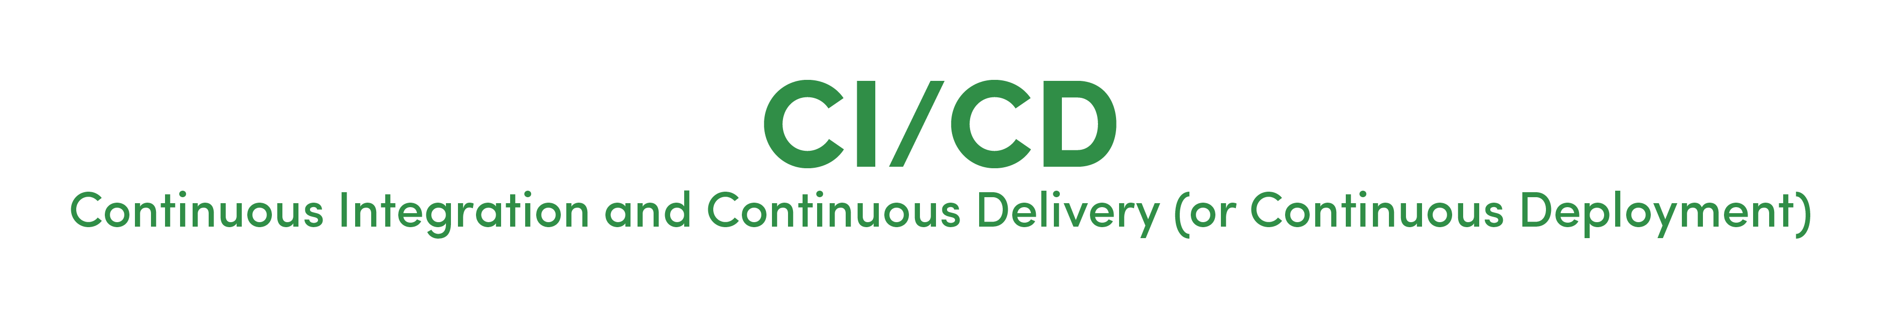

Planning -Documenting and determining project structure and schedule.

Analysis -Analyzing project requirements and collecting resources.

Design -Designing software model with architecture and Interface designing.

Implementation -Developing an actual product by considering design and requirements.

Testing -Testing the built, fixing errors & bugs, and refactoring the code.

Deploying and Maintenance -The software is deployed and monitored for further enhancements.

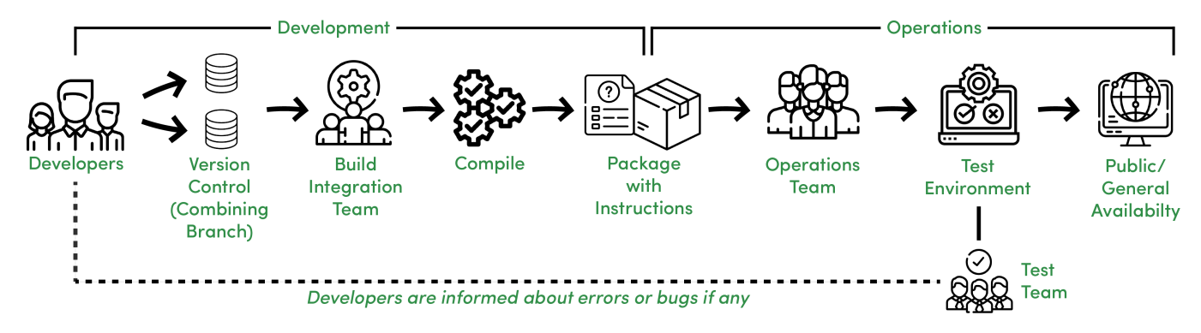

Features -

Different Development teams maintain different code repositories.

Build and Integration team integrates the code.

Integrated code is compiled as a package.

A package with instructions is sent to the Operations team.

The Operations team pushes the package into a test environment, the package is tested by the Testing team.

The Test team informs the Development team about any possible issues else gives a green signal for Production Release.

Continuous Integration :

Continuous Integration is about how developers integrate code using a shared repository multiple times a day with the help of automation.

Continuous Delivery :

Continuous Delivery is about automatically releasing software to the test or production environment.

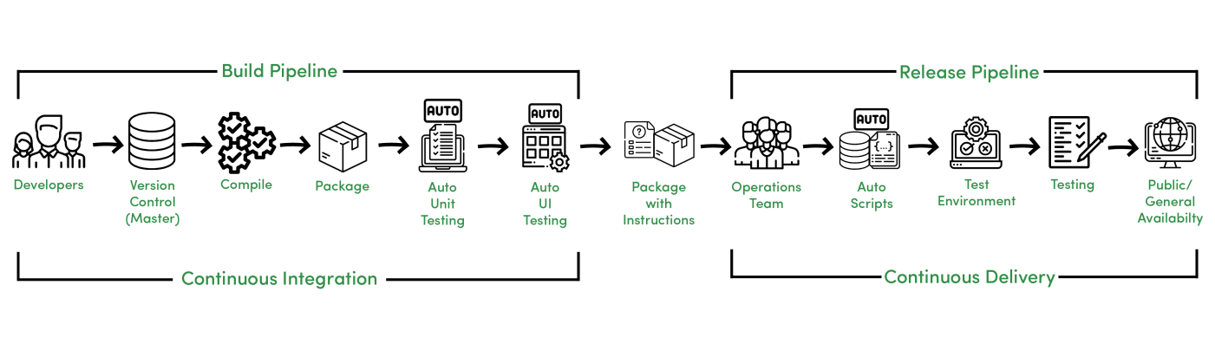

Features -

Developers manage code on a shared repository.

After compilation, Automated Unit and UI testing are performed.

The Operations Team needs to take care of Automated scripts that further go to the test environment.

Testing is performed and after approval, the software is sent to production.

Continuous Deployment :

Continuous Deployment is about releasing software to production automatically without human intervention.

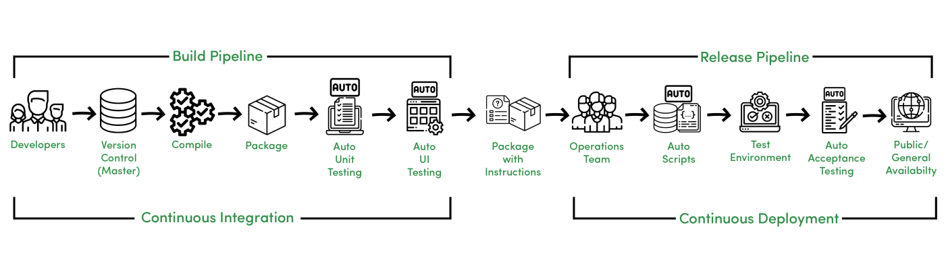

Continuous Deployment is an advancement and it reduces manual work of the Operations and Testing team to deploy the software to production as it is automatically deployed to production after Automated Acceptance Testing.

Features

Automated and quick code integration.
Error detection and response are fast due to the short cycle and iterations.

Less prone to human errors.

Faster than following manual instructions due to automated scripting.

Deployment can be done several times a day.

CI/CD Pipeline - System Design

Ci/cd stands for continuous integration and continuous deployment and is an essential pratice in modern software development it focuses on automating and streamlining the process of integrating code changes, testing & deploying software.

1. Continuous Integration (CI)

Continuous Integration (CI) is the core practice of the CI/CD pipeline. It means developers frequently merge small code changes into a shared repository instead of doing large merges later.

How CI Works
Developers push code regularly (daily or hourly).
Each push automatically triggers:
Application build
Automated tests (unit + integration)

Types of CI Tests

Unit Tests: Verify small, individual components.

Integration Tests: Ensure different parts of the application work correctly together.

Main Goal of CI

Detect integration issues early, when they are easiest and cheapest to fix.

Avoid “integration hell”, which happens when large code changes are merged late and cause:

Massive conflicts.

Hidden bugs.

Long debugging cycle.

2. Continuous Delivery (CD)

Continuous Delivery (CD) extends Continuous Integration by automating everything needed to prepare code for production release. Where CI stops after building & testing, CD starts and moves the validated artifact through pre-production environments.

How CD Works

After CI passes, the pipeline automatically deploys the build to:

Testing environment

Staging environment

These environments mimic production to ensure reliability.

What Tests Run in CD?

CD runs deeper and longer tests, such as:

End-to-end (E2E) tests

Performance tests

Security scans

User Acceptance Tests (UAT)

Main Goal of CD

Ensure there is always a production-ready build that has passed all automated checks.

Enable releases at any time with confidence and stability.

3. Continuous Deployment (CD)

Continuous Deployment (CD) is the highest level of automation in the CI/CD pipeline. It takes Continuous Delivery one step further by removing the final manual approval and automatically deploying every validated change straight to production.

How Continuous Deployment Works

A code change passes all automated checks in:

CI (build + unit tests + integration tests)

CD (E2E tests, performance tests, security tests)

If all tests succeed, the change is immediately deployed to production. No human intervention is required.

Stage 1: Source

The Source stage is the entry point and trigger for the entire CI/CD pipeline. It is intrinsically linked to the version control system, which acts as the single source of truth for the codebase.

Trigger: The pipeline run is initiated by an event in the VCS. The most common trigger is a git push to a specific branch (like main or develop), but it can also be the creation or update of a pull request, the creation of a Git tag, or even a scheduled event.

Pre-flight Checks: Before committing to resource-intensive build and test processes, the pipeline performs a series of rapid, automated checks directly on the source code. This embodies the "fail fast" principle: find simple issues immediately to save time and computational resources. These checks often include:

Static Code Analysis: Tools like SonarQube scan the source code without executing it to identify potential bugs, logical errors, code smells, and overly complex constructs that might lead to future problems.

Linting: Linters enforce a consistent coding style and formatting across the codebase. This improves readability and maintainability, which is crucial for collaborative projects.

Security Scanning (SAST): Static Application Security Testing (SAST) tools analyze the source code for known security vulnerabilities, such as SQL injection or cross-site scripting flaws, before the code is even compiled.

Stage 2: Build

Once the source code passes the initial checks, the Build stage transforms it from human-readable code into a runnable, packaged application.

Compilation: The source code is compiled into an executable format. For a Java or.NET application, this means compiling source files into bytecode. For a front-end application using TypeScript or modern JavaScript, this involves transpiling and bundling the code into static assets that a browser can understand.

Dependency Management: The build process fetches and installs all the necessary libraries, frameworks, and other dependencies that the application requires to run.

Artifact Creation: The compiled code, its dependencies, static assets, and configuration files are all packaged together into a single, versioned, deployable unit known as a build artifact. In modern, cloud-native development, the most common form of artifact is a Docker container image. Other examples include .jar or .war files for Java, NuGet packages for.NET, or a simple ZIP file.

Immutability: A core principle of a robust pipeline is that this artifact is immutable. The exact same artifact created in this stage—with a unique version identifier—is what will be used in all subsequent testing and deployment stages. This ensures consistency across all environments and eliminates the classic "it works on my machine" problem, as the unit being tested is identical to the unit that will be deployed.

Stage 3: Test

The Test stage is where the build artifact is subjected to a rigorous and multi-layered validation process to ensure its quality, correctness, and stability. This stage is often the most time-consuming part of the pipeline and is composed of several sub-stages of automated testing.

Unit Tests: These are the foundation of the testing pyramid. Unit tests validate the smallest individual pieces of the code, such as a single function or class, in isolation from the rest of the application. They are typically written by developers, are very fast to execute, and provide precise feedback about which component has failed.

Integration Tests: These tests verify that different components, modules, or services of the application can work together correctly. For example, an integration test might check that the application can successfully write data to and read data from a database, or that two microservices can communicate via their APIs as expected.

End-to-End (E2E) Tests: These tests validate the entire application workflow from the perspective of the end-user. They simulate real user scenarios, driving the application through its user interface to verify that the complete, integrated system functions as expected. For example, an E2E test for an e-commerce site might automate the process of a user logging in, adding an item to the cart, and completing a purchase.

Compliance & Security Testing: Beyond functional correctness, this stage can include further automated checks. Compliance testing can verify that the artifact adheres to organizational or regulatory policies.Dynamic Application Security Testing (DAST) tools can probe the running application for security vulnerabilities that are only discoverable at runtime.

Stage 4: Deploy

After the build artifact has successfully passed all automated tests, the Deploy stage is responsible for releasing it to various environments and, ultimately, to end-users.

Environment Promotion: The validated artifact is promoted through a sequence of environments, each serving a specific purpose. A common progression is from a Development environment to a Staging (or Pre-production) environment, which should be a near-exact replica of production. After validation in staging, it may go to a User Acceptance Testing (UAT) environment for manual review before finally being deployed to the Production environment for end-users.

Deployment Strategies: The final deployment to production is a critical and high-risk step. To manage this risk, modern pipelines employ sophisticated deployment strategies to ensure a smooth release with minimal or zero downtime. These strategies, such as Rolling, Blue-Green, or Canary deployments, control how the new version is introduced to the production infrastructure and how traffic is shifted to it.21

Infrastructure as Code (IaC): In modern cloud-based systems, this stage often involves more than just deploying the application artifact. It can also include provisioning or updating the underlying infrastructure (virtual machines, databases, load balancers) required to run the application. This is achieved using Infrastructure as Code (IaC) tools like Terraform, AWS CloudFormation, or Azure Resource Manager, where the infrastructure configuration is defined in code and managed through the same version-controlled, automated pipeline as the application itself.

6. Setting Up a CI/CD Pipeline

Setting up a CI/CD pipeline involves several stages, from configuring your version control system to deploying your application. Below are detailed steps to set up a CI/CD pipeline using a common tool like Jenkins, but the concepts can be applied to other CI/CD tools as well:

Step 1. Install and Configure Jenkins

Download Jenkins: Go to the Jenkins website and download the appropriate installer for your operating system.

Install Jenkins: Follow the installation instructions for your operating system.

Start Jenkins: After installation, start Jenkins and access it via http://localhost:8080.

Step 2. Set Up Version Control System (VCS)

Choose a VCS: Use Git, GitHub, GitLab, Bitbucket, etc.

Create a Repository: Create a new repository or use an existing one.

Commit Code: Ensure your code is committed to the repository.

Step 3. Install Required Plugins in Jenkins

Git Plugin: For connecting Jenkins with your Git repository.

Pipeline Plugin: For defining Jenkins pipelines.

Other Plugins: Depending on your project requirements (e.g., Maven, Docker, NodeJS).

Step 4. Create a New Jenkins Pipeline Job

New Item: From the Jenkins dashboard, click on “New Item”.

Pipeline: Select “Pipeline” and give your job a name.

OK: Click “OK” to create the job.

Step 5. Configure the Pipeline Job

Pipeline Script from SCM: Under the “Pipeline” section, select “Pipeline script from SCM”.

SCM: Select “Git” and provide the repository URL.

Branch Specifier: Specify which branch to build (e.g., */main).

pipeline {
agent any

stages {
stage('Checkout') {
steps {
// Clone repository
git url: 'https://github.com/your-repo.git', branch: 'main'
}
}
stage('Build') {
steps {
// Build your project
sh './gradlew build'
}
}
stage('Test') {
steps {
// Run tests
sh './gradlew test'
}
}
stage('Deploy to Staging') {
steps {
// Deploy to staging environment
sh './deploy.sh staging'
}
}
stage('Deploy to Production') {
when {
branch 'main'
}
steps {
// Deploy to production environment
sh './deploy.sh production'
}
}
}
}

Step 7. Trigger Builds Automatically

Webhooks: Set up webhooks in your VCS to trigger Jenkins builds automatically on commits.

Poll SCM: Alternatively, you can configure Jenkins to poll the SCM periodically.

Step 8. Monitor and Manage Builds

Build Dashboard: Monitor build status from the Jenkins dashboard.

Logs: Check build logs for details on failures and successes.

Notifications: Configure email or chat notifications for build results.

Step 9. Secure Your Pipeline

Access Control: Set up proper access controls in Jenkins to ensure only authorized users can modify the pipeline.

Secrets Management: Use Jenkins credentials plugin to manage sensitive information securely.

Step 10. Optimize and Scale

Parallel Builds: Configure Jenkins to run builds in parallel to speed up the process.

Distributed Builds: Set up Jenkins agents on multiple nodes to distribute the load.
Pipeline as Code: Keep your pipeline configuration in the repository (Jenkins-file) to version control your CI/CD process.

7. Pipeline Orchestration

Pipeline orchestration in system design involves managing and automating the various stages of a CI/CD pipeline to ensure smooth and efficient delivery of software. Orchestration ensures that each stage of the pipeline, from code commit to production deployment, is executed in the correct order and according to predefined rules.

How to Build a CI/CD Pipeline with AWS

Building and deploying code manually every time takes a lot of effort and can lead to mistakes. A CI/CD pipeline makes this easier by automating testing, building, and deploying your code.

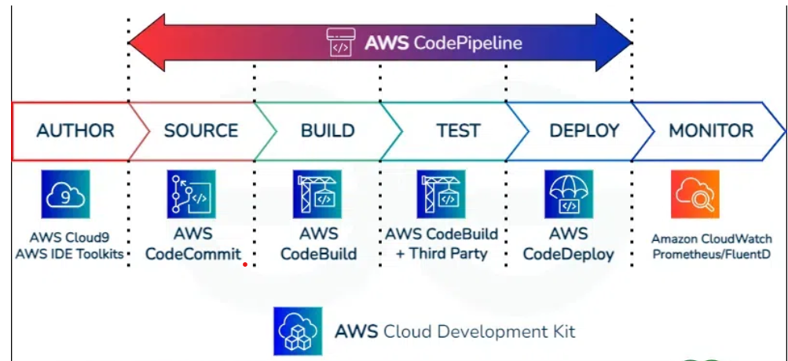

CI/CD on AWS means using cloud tools to automate the entire software development process, from writing code to testing and launching apps. This approach helps teams build, test, and release software faster and more reliably.

AWS provides special services to make this process easier:

AWS CodePipeline: connects all the steps of the software release process.

AWS CodeBuild: automatically compiles code and runs tests.

AWS CodeDeploy: sends the final app to servers or the cloud for users to access.

AWS also encourages teams to manage infrastructure using code, known as Infrastructure as Code (IaC). This helps ensure everything is consistent and easy to scale. CI/CD on AWS helps developers deliver updates quickly and with fewer errors, by automating and simplifying the whole process.

AWS CI/CD works by improving the combination of AWS services and practices the automation of software development lifecycle from code integration to deployment. The Operations of AWS CI/CD is breakdown as follows:

AWS CodePipeline Orchestration: CodePipelines acts as an orchestrator in defining the workflows and stages of the CI/CD process.

Integration With Source Control: It provides a seamless integration with source code repositories like Github, AWS CodeCommit, Bitbucket for knowing changes in the source code.

Continuous Integration (CI)

AWS CodeBuild: When any changes are detected in the source code CodePipeline notifies it to the CodeBuild. Then CodeBuild build and compile the changes in the source code.

Artifacts Generation: CodeBuild uses the build process to generate deployable artifacts, such as binaries or packages. It helps in deploying the artifacts to the specified deployment targets may include Amazon EC2
instances, on-premises servers, or Lambda functions.

Continuous Deployment (CD)

AWS CodeDeploy: After once Build and Test stages are successful then CodePipeline will triggers CodeDeploy to automate the deployment process.

Deployment Configurations: CodeDeploy facilitates users in defining deployment configurations. Users can specify how they want to proceed the deployment such as canary deployments for gradual rollouts.

Rollback Mechanism: CodeDeploy facilitates easy rollbacks to previous code applications, In case of any issues arises during deployment.

Continuous Monitoring

CloudWatch: AWS CloudWatch offers monitoring features for users in creating alerts on the functionality and health of their deployed applications.

Log And Metrics: Services like CodePipeline, CodeBuild, and CodeDeploy helps in generating logs and metrics for supporting in troubleshooting and performance analysis of the CI/CD pipeline.

Collaboration And Visibility

Integration With AWS Services: AWS CI/CD tools supports integration with other AWS services such as AWS CodeCommit, Amazon S3, Elastic Beanstalk, and more for providing a complete platform.

Dashboard And Notifications: AWS comes with providing a user-friendly dashboard for visualizing the pipeline stages and notifications for pipeline events.

Infrastructure as Code (IaC)

AWS CloudFormation: AWS allows users in defining and provisioning of infrastructure with Infrastracture as Code scripts using the services such as CloudFormation for ensuring consistency across the environments.

AWS CI/CD facilitates with automation of building, testing, and deployment phases of software application providing an optimized and efficient workflow. It promotes collaboration, visibility, and reliability in the software development process. The combination of AWS CodePipeline, CodeBuild, and CodeDeploy services makes a powerful CI/CD solution within the AWS ecosystem.

Step 1: Create IAM Role for EC2 and AWS CodeDeploy

Navigate to IAM service.

Then go to roles and create a new role.

Select trusted entity type as AWS Service and use case as EC2

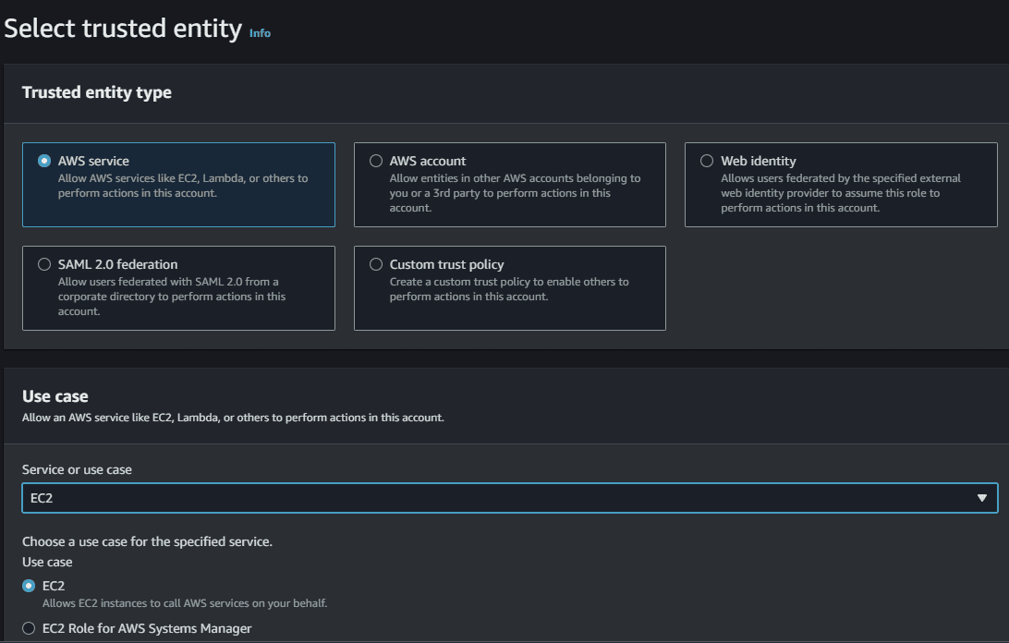

Step 2: Add permissions To IAM Role

Select AmazonS3ReadOnlyAccess permission. It will allow our EC2 instance to access stored artifacts from the Amazon S3 bucket.

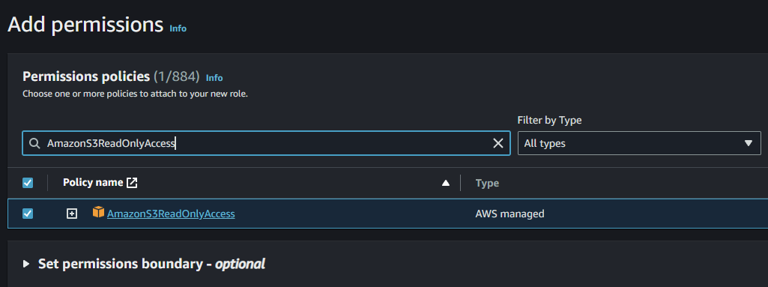

Step 3: Creating The Role For AWS CodeDeploy

Provide the Name, review and Click on Create for creating the Role.

Select an appropriate role name and click on create role.

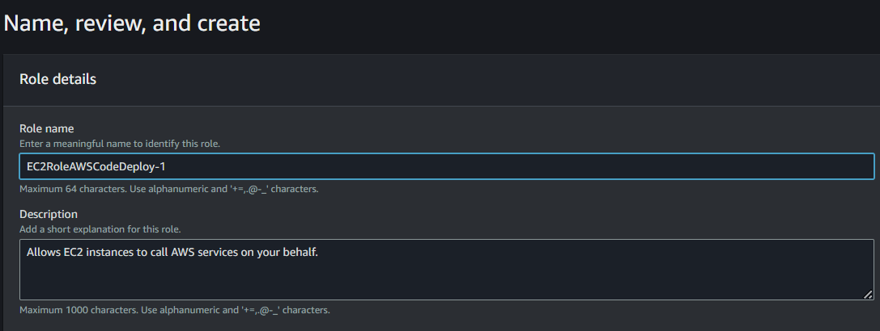

Step 4: Creating New Service Role For CodeDeploy

Create a new service role for CodeDeploy and attach AWSCodeDeployRole policy which will provide the permissions for our service role to read tags of our EC2 instance, publish information to Amazon SNS topics and much more task.

Repeat the Above 3 steps again with trusted entity type AWS Service, use case CodeDeploy.

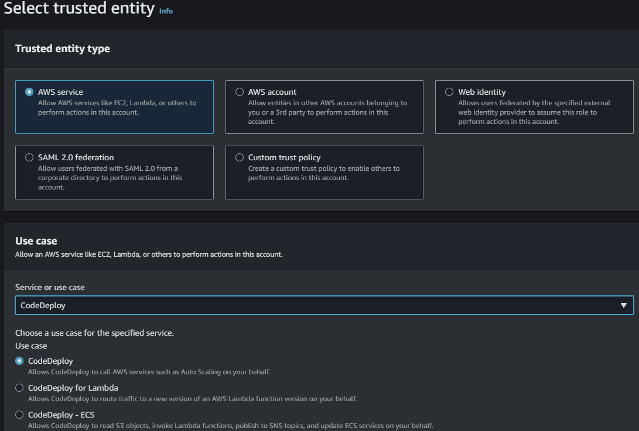

Add AWSCodeDeployRole permissions to this creating Role

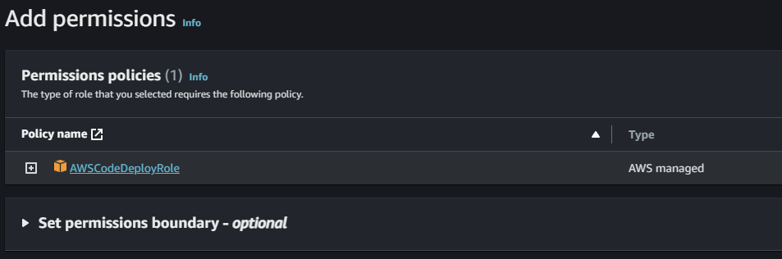

Provide the Name, review and create the role.

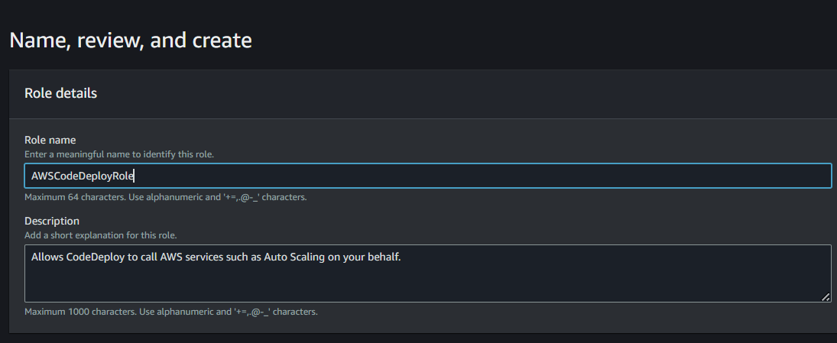

Step 5: Launch An Linux EC2 instance

Select the instance with AMI such as "Amazon Linux" and connect to CLI Console.

Switch to root user from ec2-user to gain admin access power by using following command "sudo su" in Linux.

sudo su

Step 6: Update The Packages

The command "sudo yum update" is used in Amazon Linux, CentOS, and Red Hat Linux distributions to update installed packages on your system to their latest available versions.

sudo yum update

Step 7: Install The Ruby And Wget Software

The command 'sudo yum install ruby' is used to install the Ruby programming software using the YUM package manager.

sudo yum install ruby

The command sudo yum install wget is used to install the "wget" package on a system running Amazon Linux, CentOS, or other Red Hat-based Linux distributions that use the YUM package manager.

sudo yum install wget

Step 8: Download CodeDeploy Agent Script
Downloading the AWS CodeDeploy agent installation script from the AWS S3 bucket is an essential step in setting up AWS CodeDeploy for your infrastructure.
The CodeDeploy agent is a lightweight, scalable software component that enables AWS CodeDeploy to deploy and manage applications on your EC2 instances or on-premises servers.
wget https://aws-codedeploy-us-east-1.s3.amazonaws.com/latest/install

Step 9: Run Installation Script
The command chmod +x ./install is used to make a file executable in a Unix-like operating system, including Linux.
chmod +x ./install

The command 'sudo ./install auto' is likely used to run an installation script with superuser (administrator) privileges and pass the "auto" argument to the script.
Step 10: Check CodeDeploy Agent Status
The command sudo service codedeploy-agent status is used to check the status of the AWS CodeDeploy agent running on your system.
sudo service codedeploy-agent status

Step 11: Modifying IAM Role

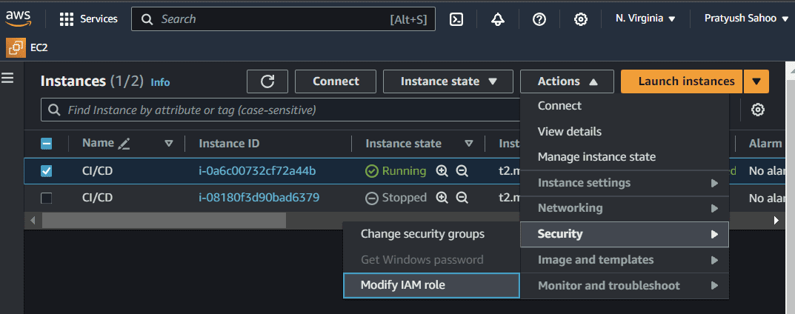

Modify the IAM role by clicking on the button Update IAM role as shown in the figure.

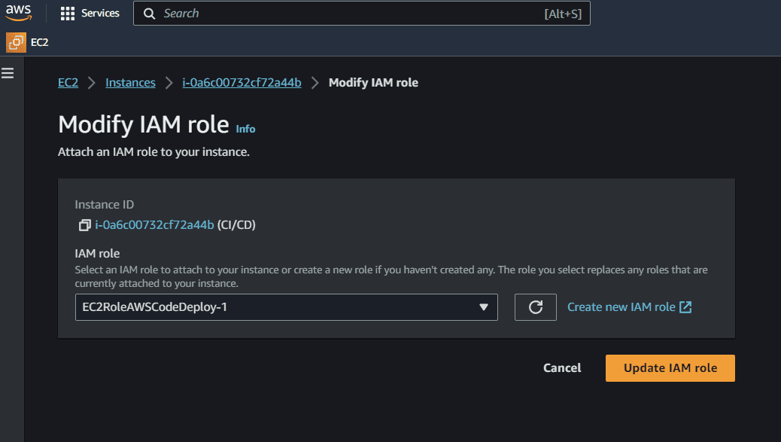

Step 12: Finalizing The Configuration
After this process, go to the console where your instance is connected and run the command "exit" to exit from the root folder and go back to the EC2 folder. Make a directory on the EC2 folder named "server", this is the directory where my source code will be deployed.
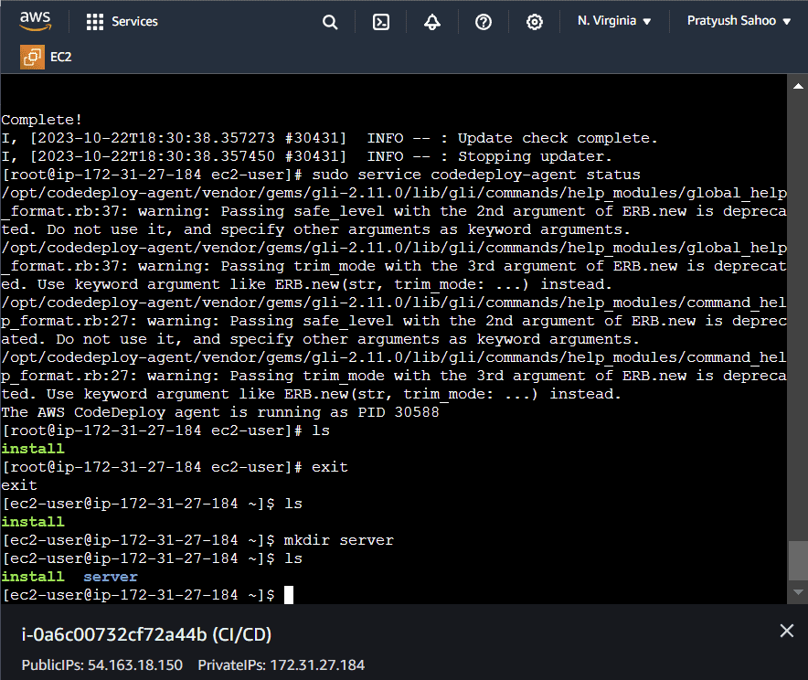

Then after doing the above process, come back to the running instances list.
Select your currently created running instance and go to the "Security" section present at the end of the page.
Click on the link present under the "Security Groups". After redirecting to the required page, click on "Edit Inbound rules" under the section of "Inbound rules" present at the end of the page.
Then add a rule, select a port range of your choice and select the source as "Anywhere-IPv4" from the dropdown menu and then click on "Save rules".
Basically, let me give you a overview what we are actually doing here. In brief, when you add an inbound rule to a security group for an instance with port range (in my case, it was 4000) and set the source to "Anywhere-IPv4," you are allowing any computer or device on the internet to connect to your instance through port 4000.
This is like opening a door (port 4000) on your server and letting anyone from anywhere access the service or application running on that port.
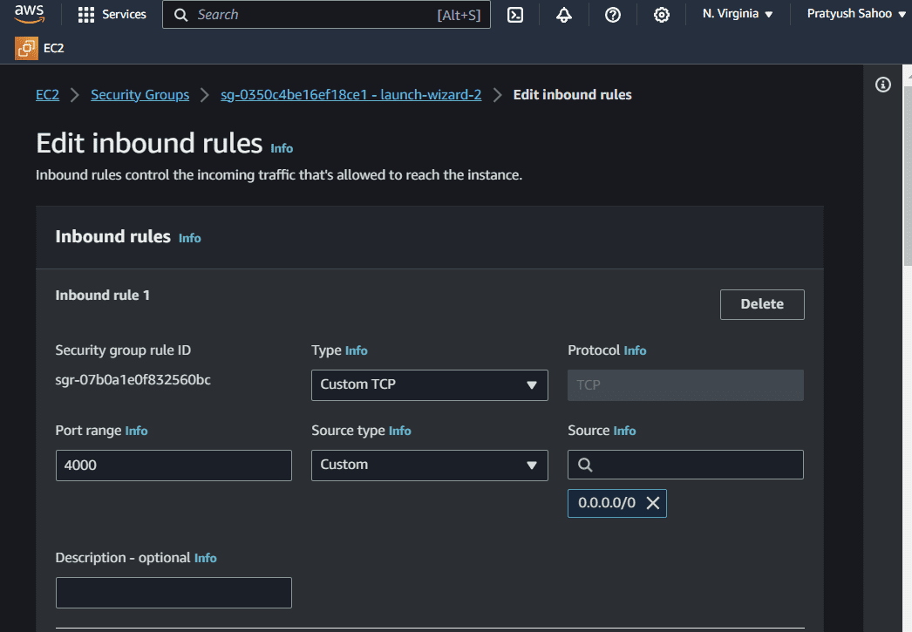

Step 13: Create A New Pipeline
Create a CodePipeline using Github, CodeBuild and CodeDeploy
Firstly Create CodePipeline navigate to CodePipeline via AWS Management Console and click on Create pipeline.
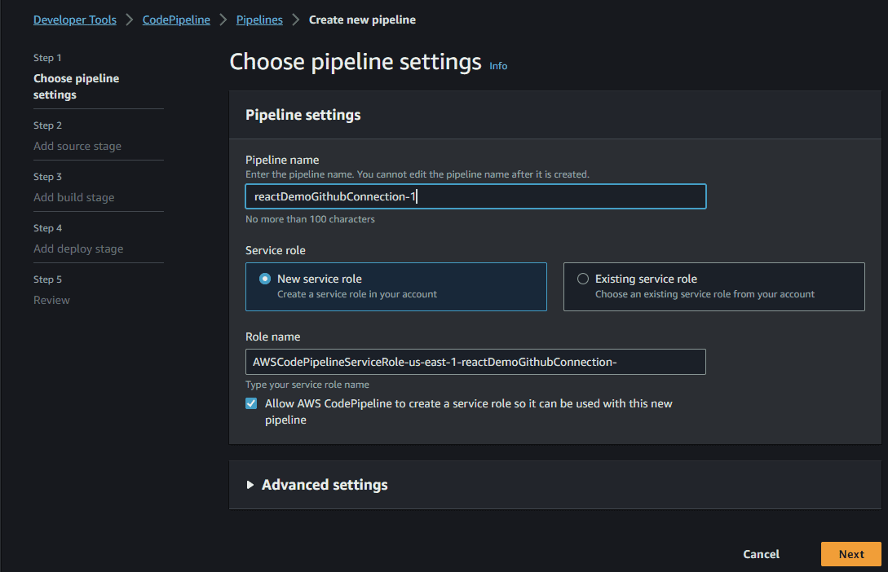

Step 14: Choose Github In Code Source
After selecting GitHub as the source provider, click on the Connect to GitHub button. You’ll then be prompt to enter your GitHub login credentials.
Once you grant AWS CodePipeline access to your GitHub repository, you can select a repository and branch for CodePipeline to upload commits to this repository to your pipeline.
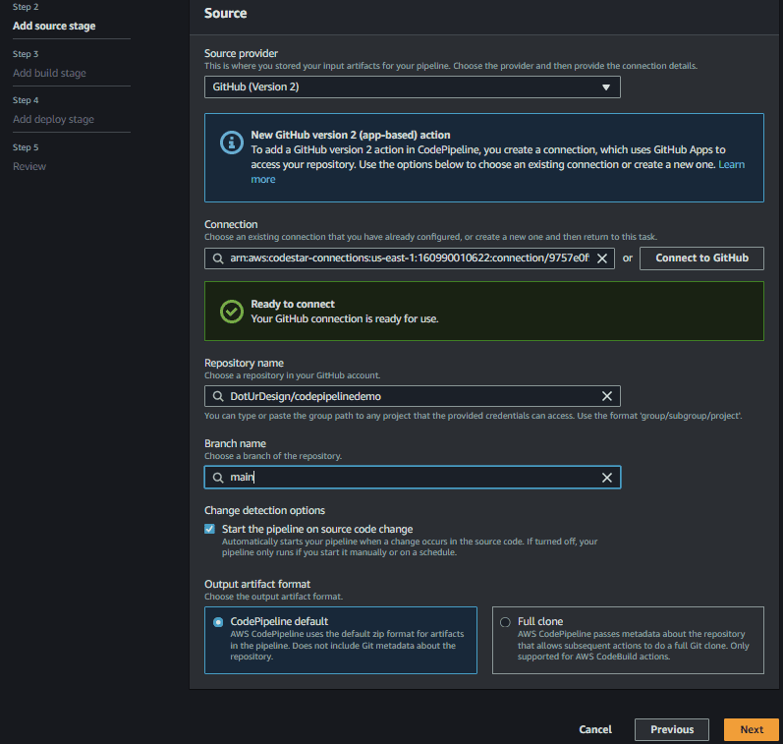

Step 15: Configure CodeBuild (Optional)

If you haven’t created a project prior to creating your pipeline, then you can create a project directly from here by clicking Create project button.
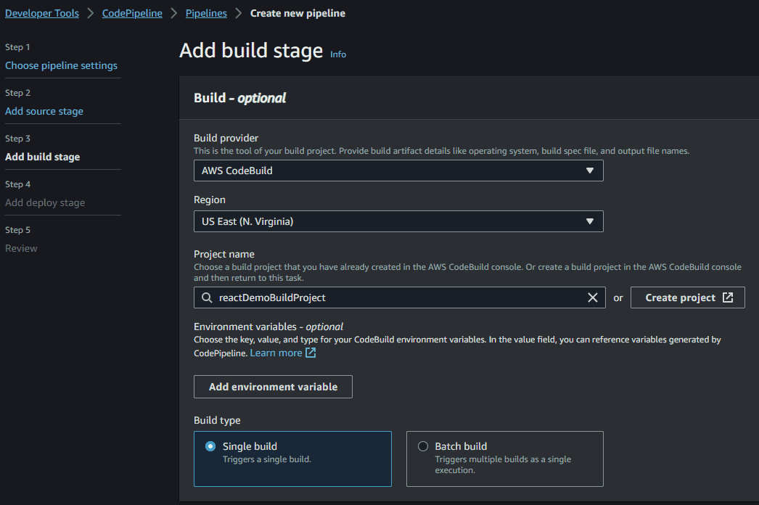

Step 16: Add Deploy Stage
Go to code deploy in the navigation, Select Application, then add create a deployment group.
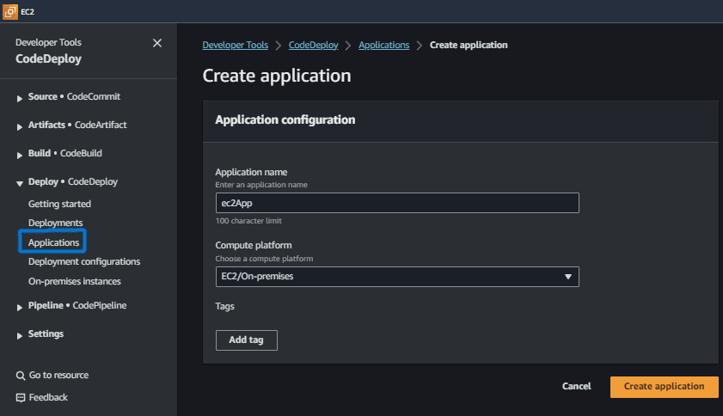

Create a deployment Group by clicking on the button "Create deployment group", the following screenshot illustrates with practically.
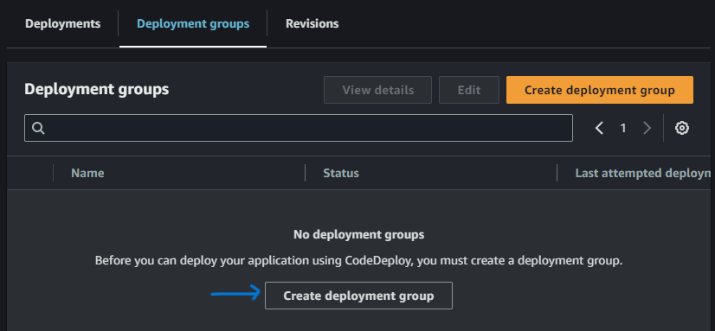

In deployment group Select EC2 instances and select Tag and Value

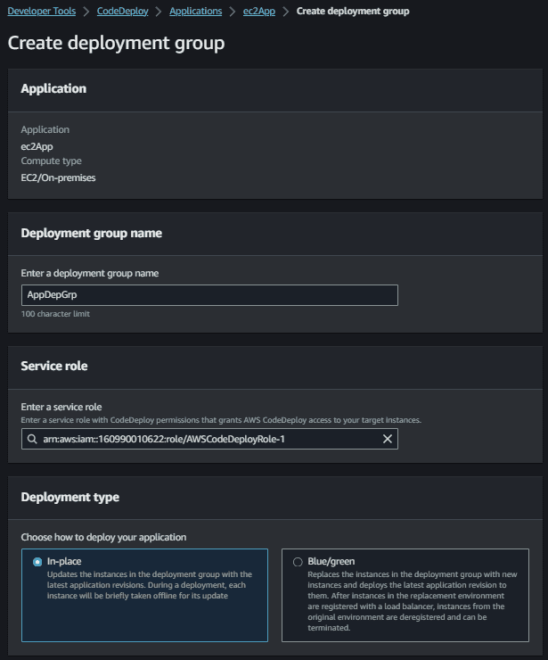

Provide the Environment configurations such as select the Amazon EC2 Instances and provide the key and values to it.
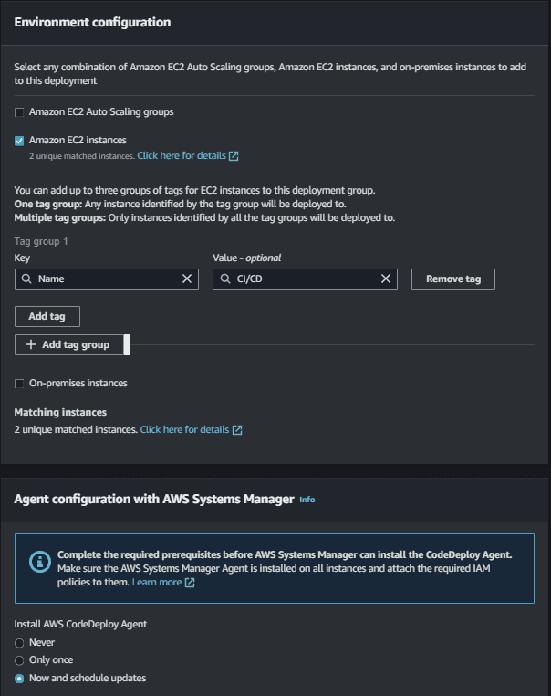

Uncheck Load Balancer Option
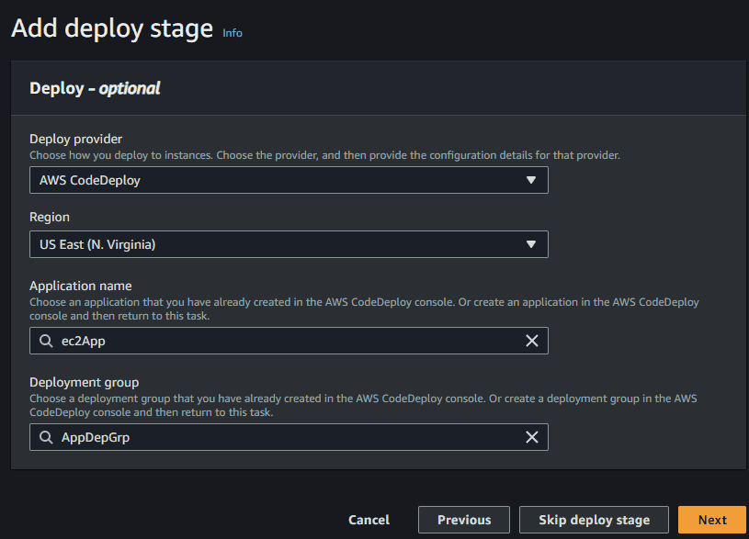

Step 17: Review And Create
As a final step review and create it. By creating this we have successful the created a CI/CD pipeline in AWS.

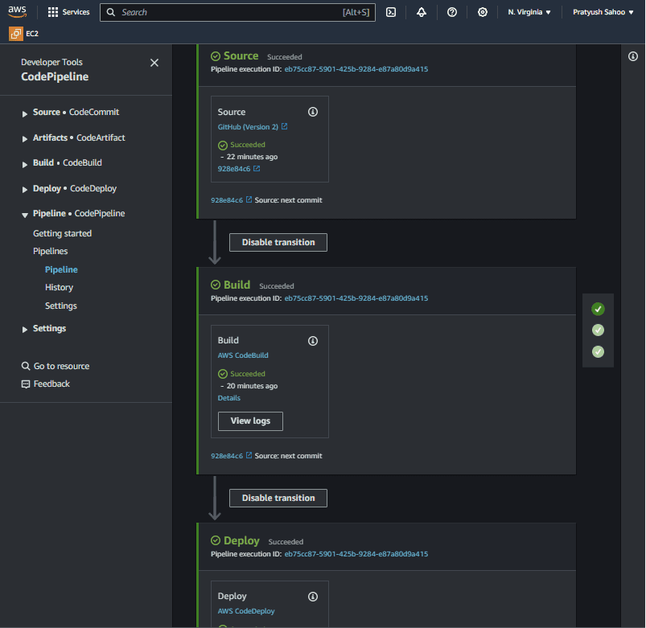

To deploy a simple web application using AWS CodeCommit, CodeBuild, CodeDeploy, and CodePipeline, you will set up a CI/CD pipeline that automatically builds and deploys your code to an EC2 instance whenever changes are pushed to your repository.

Step-by-Step Deployment
1. Create a CodeCommit Repository
Navigate to the AWS CodeCommit console and choose Create repository.
Provide a name for your repository and create it.
Follow the instructions to configure your local machine to interact with CodeCommit (using HTTPS Git credentials is a common method).
Clone the empty repository to your local machine and add your sample application files, including appspec.yml and buildspec.yml.
Commit and push the code to the CodeCommit repository using Git commands:
bash

git add -A
git commit -m "Add sample application files"
git push

2. Create a CodeDeploy Application
Navigate to the AWS CodeDeploy console and choose Create application.
Enter an application name and select EC2/On-premises as the compute platform.
Choose Create deployment group.
Specify a name for the deployment group and select an appropriate IAM Service role (you may need to create a new one with the AWSCodeDeployRole managed policy).
Under Environment configuration, select Amazon EC2 Instances and specify the Key (e.g., Name) and Value (e.g., MyCodePipelineDemo) tags of your target EC2 instance.
Under Deployment configuration, choose an option (e.g., CodeDeployDefault.OneAtATime) and ensure Enable load balancing is unchecked for this simple deployment.
Choose Create deployment group.
3. Create the CodePipeline
Navigate to the AWS CodePipeline console and choose Create pipeline.
In Step 1: Choose pipeline settings, provide a pipeline name and choose a New service role to allow CodePipeline to create an IAM role on your behalf. Choose Next.
In Step 2: Add source stage, configure the source:
Source provider: Select AWS CodeCommit.
Repository name: Select the repository you created earlier.
Branch name: Select the appropriate branch (e.g., main or master).
Leave Change detection options at their defaults (using Amazon CloudWatch Events).
Choose Next.
In Step 3: Add build stage, select AWS CodeBuild as the build provider.
Choose Create project. A new window will open where you can configure the build project details, including the operating system and the service role, and specify to use an existing buildspec.yml file from your repository.
After creating the project, return to the pipeline creation and select the newly created build project name.
Choose Next.
In Step 4: Add deploy stage, configure the deployment:
Deploy provider: Select AWS CodeDeploy.
Application name: Select the CodeDeploy application you created.
Deployment group: Select the deployment group you created.
Choose Next.
In Step 5: Review, review your settings and choose Create pipeline.

Accessing the Web Application
After creation, the pipeline will start automatically. You can monitor the progress through each stage (Source, Build, Deploy) in the CodePipeline console.
Once the "Deploy" stage shows Succeeded, navigate to the Amazon EC2 console.
Select your instance and copy its Public IPv4 address or Public DNS name from the Details tab.
Paste the address into your web browser. You should see your web application running.

